**Test Cases for Feature #2: Unit Tests for View maze stored in memory**

|  |  |  |  |  |
| --- | --- | --- | --- | --- |
| **Test Scenario** | **Test Description** | **Test Values** | **Expected**  **Outcome** | **Actual**  **Outcome** |
| 1. | Test for displaying maze when the list is empty. | mazeList = [ ] | Error messages will be shown.  “No maze loaded.” Program will exit back to the main menu. | Message shown:  “Option [2] View Maze  =========================================” |
| 2. | Test for displaying maze when list is loaded. | mazeList = [“X”, “X”,”X”, “X”, “O” ,”X”  … …] | The maze would be loaded  and displayed. | Maze displayed  “[“X”, “X”,”X”, “X”, “O” ,”X”  … …]” |

1.Test for displaying maze when the list is empty

1. Input option 2 into prompt.

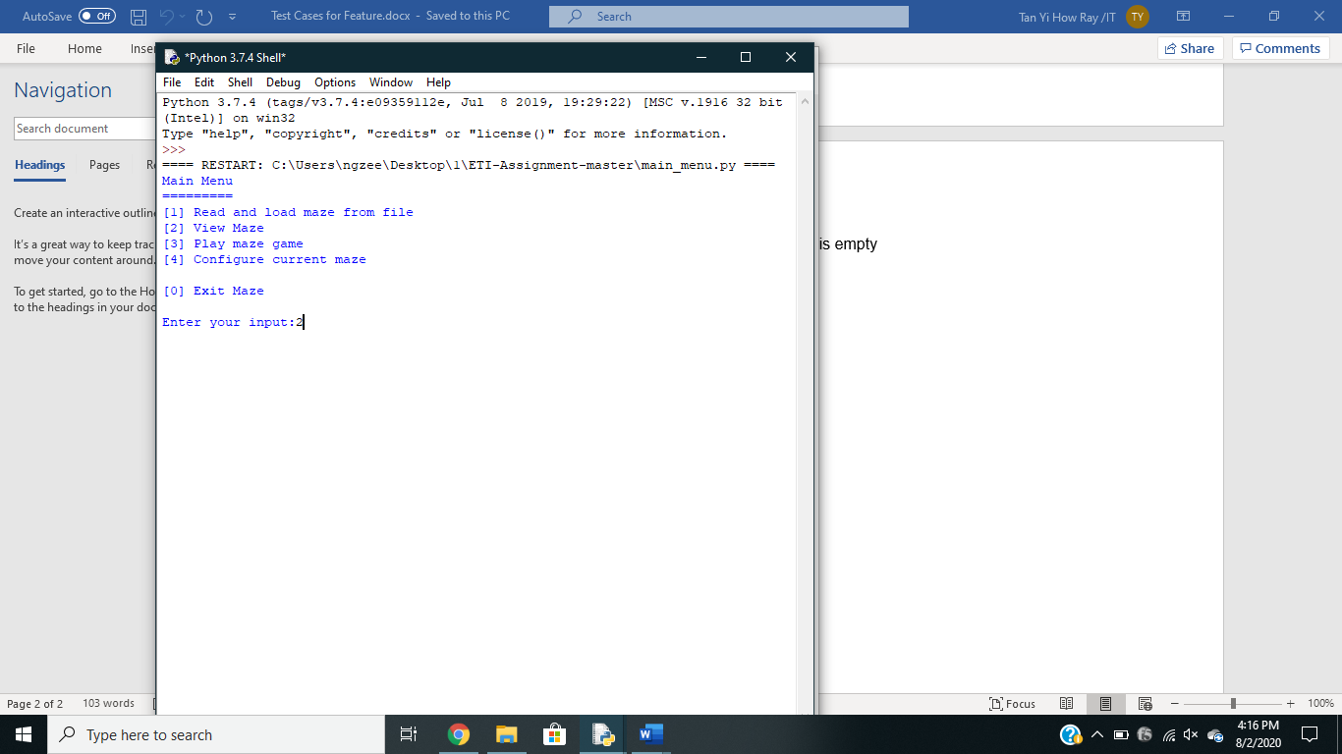

* 1. Error message prompt “Option[2] View Maze” as there is no list stored.

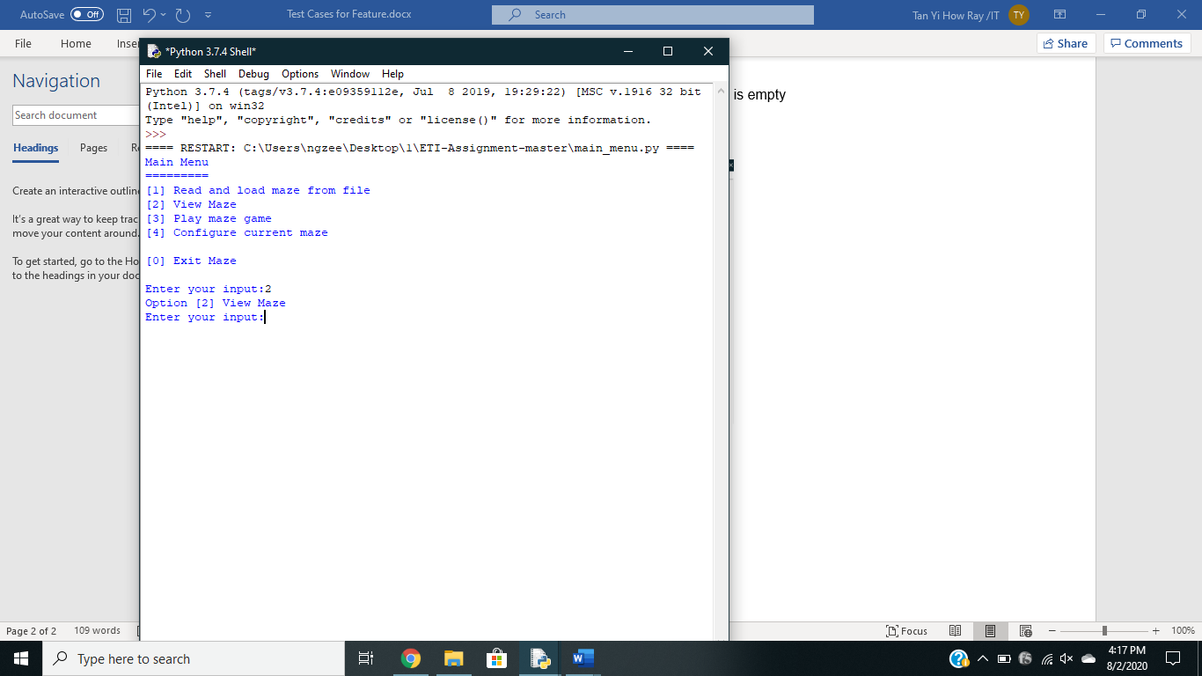

1. Test for displaying maze when list is loaded.

2.0 Input option 1 into prompt.

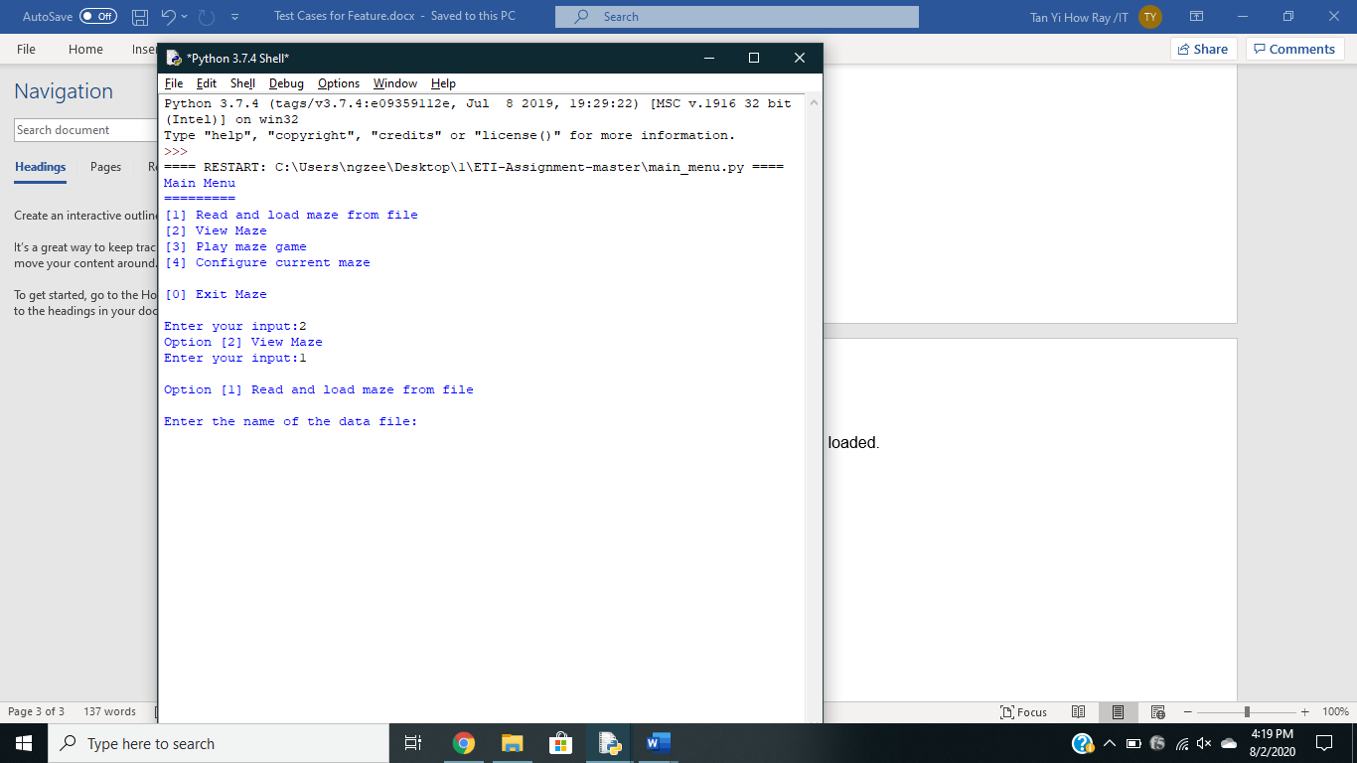

2.1 Input file name “Maze.csv” into prompt , now list is stored in stored memory.

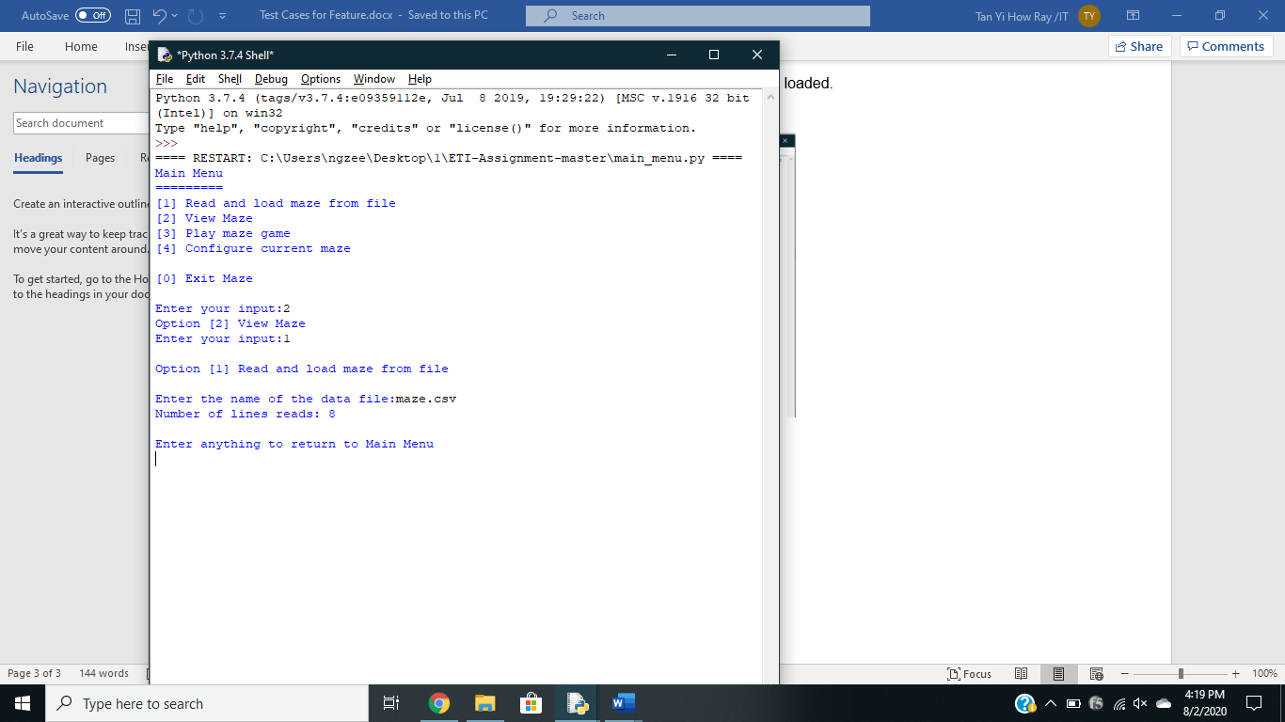

2.2 Input option 2 into prompt , stored memory list will be displayed.

